Module: FC723
Groub: C
Module Title: Programming Theory
Assessment Title: Portfolio Project 1
Tutor Name: Sophie Norman
Student GUID Number: 3075614
P Number: P461989
Date of Submission: 26th January 2025 at 23:59

- The Pseudocode:
This was the initial pseudocode.
1-define function take input The first number, the second number to find the GCD
2-check if the first number or the second number equal to zero. if yes we return the other
3-if not we use the function again using recursion concept.

The pseudocode was not very accurate, but it gave me a path to work on to know in what I should work on next. The pseudocode in the git repository is edited one after spotting the order of the inputs problem.

- How does the code works:

class Math:

def find_the_greatest_common_factor(Num1,Num2):
if Num1==0:
return Num2
if Num2==0:
return Num1
else:

The_remainder=Num1%Num2
return Math.find_the_greatest_common_factor(Num2,The_remainder)

The basic idea of the code is to divide the reminder by the second number until one of them is zero so the answer will be the other number following the Euclidean Algorithm.
I applied the idea using the recursion concept which I learned in the week 5 in FC724 when we were asked to convert a nested list to flatten list.
After using the pseudocode to write the code I had some issues with the way that I implement the Euclidean Algorithm like the order of putting the numbers
After that I refactored the code to put the function in an appropriate class. Also adding error message when an invalid input is given as shown below.
v, checks if the input is string if yes will return error with message "The Input Should Be Intger Or Float"
if isinstance(Num1 , str) or isinstance(Num2, str):
raise ValueError("The Input Should Be Intger Or Float")
# v, checks if the input are 0 and 0 if true will return erorr with message "The GCD between 0 and 0 is mathematically undefined"
if Num1==0 and Num2==0:
raise ValueError("The GCD between 0 and 0 is mathematically undefined")

- Test The Code:
I used unit test to test the function which we learned in FC723 Week 10. I write the following code to test the function.

import the_euclidean_algorithm_code_refactored as ss

def test_find_the_greatest_common_factor():
GCD= ss.Math.find_the_greatest_common_factor(0, 3)
assert GCD== 3, "The greatest common factor"

This code shows the expected output of the find_the_greatest_common_factor function when we put 0 and 3 as parameters, which means finding the greatest common factor for 0 and 3. And the expected output is 3.
Running the test :
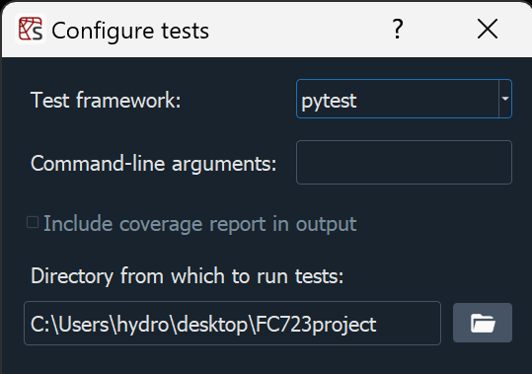
Result:
